Define ui, explain two essential components, factors.

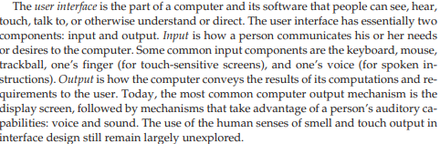

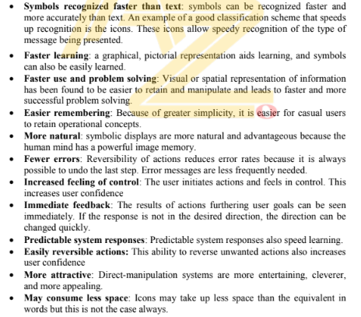

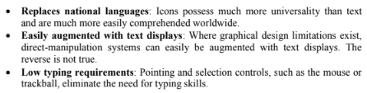

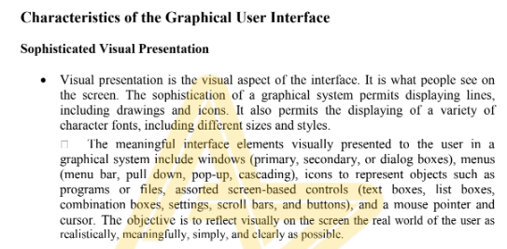

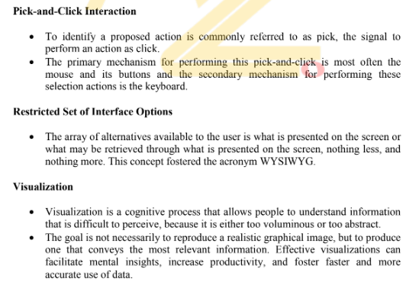

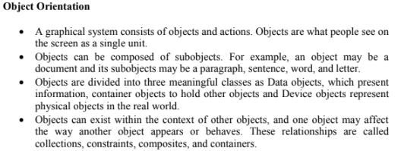

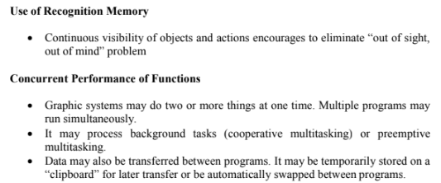

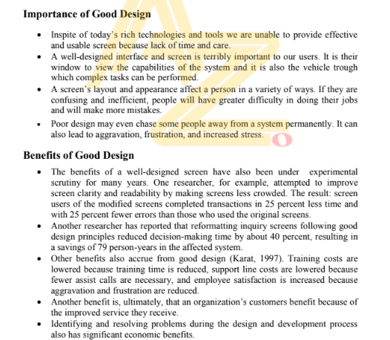

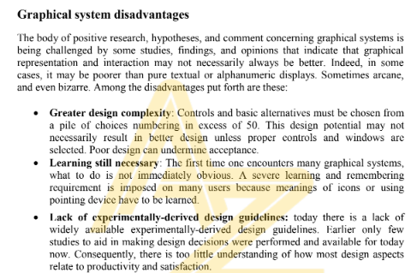

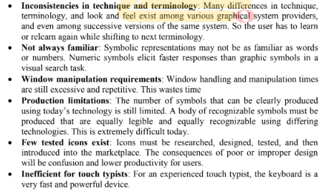



general principals of uid

* **User-Centered Design:** UID, in the context of User Interface Design, revolves around the needs and preferences of the users. Designers should prioritize creating interfaces that are intuitive and easy for users to understand and navigate.
* **Consistency:** Maintain consistency throughout the interface to provide a seamless experience. Consistent design elements, patterns, and behaviors help users predict how the interface will respond in different situations.
* **Clarity and Simplicity:** Keep the interface simple and clear. Avoid unnecessary complexity or clutter that could confuse users. Use straightforward language, easily recognizable icons, and logical layouts.
* **Feedback:** Provide feedback to users for their actions. This can be in the form of visual cues, sound, or messages, helping users understand the outcome of their interactions with the interface.
* **Hierarchy and Prioritization:** Establish a clear hierarchy in the design to guide users' attention and prioritize information based on its importance. This helps users quickly understand the structure of the content.
* **Flexibility and Efficiency:** Design interfaces that accommodate a range of user needs and allow for efficient interactions. Users should be able to perform tasks quickly and with minimal effort.
* **Accessibility:** Ensure that the interface is accessible to users with diverse abilities and disabilities. This includes considerations for different devices, screen sizes, and assistive technologies.
* **Aesthetics:** While functionality is crucial, the visual appeal of an interface can also impact user experience. Strive for a visually pleasing design that aligns with the overall brand identity.
* **Error Prevention and Recovery:** Anticipate possible user errors and provide mechanisms for recovery. Clear error messages and options for correction help users navigate through mistakes.
* **User Testing:** Regularly test the interface with actual users to gather feedback and identify areas for improvement. User testing helps validate design decisions and ensures that the interface aligns with users' expectations.

"humans are complex organisims with a variety of attributes that have an important influence on interface and screen design". justify and explain

Certainly! In the realm of user interface (UI) design, the complexity of humans plays a pivotal role in shaping the design process. Here's a more focused explanation:

Cognitive Load and Information Processing:

Humans have limited cognitive resources. UI designers must be mindful of this limitation and design interfaces that minimize cognitive load. This involves simplifying information presentation, organizing content logically, and providing clear visual hierarchy to assist users in processing information efficiently.

Visual Perception and Attention:

Human vision and attention are selective. UI designers consider principles of visual perception, such as Gestalt principles, to create interfaces that guide users' attention to key elements. Using contrasting colors, clear typography, and well-defined visual elements helps in creating interfaces that are visually appealing and easy to understand.

Motor Skills and Interaction Design:

Humans interact with interfaces using various devices, each with its own input method. UI designers must consider the diversity in users' motor skills and design interfaces with appropriate touch targets, button sizes, and interactive elements. This ensures a seamless and comfortable interaction experience across different devices.

User Feedback and Affordances:

Humans rely on feedback to understand the outcome of their actions. UI designers incorporate feedback mechanisms, such as visual cues and response times, to provide users with a sense of control and understanding. Affordances, which suggest the functionality of elements, contribute to an intuitive interface design.

Emotional Design and User Experience:

Humans have emotional responses to design elements. UI designers leverage principles of emotional design to create interfaces that evoke positive emotions and enhance the overall user experience. Consideration of color schemes, imagery, and tone contributes to the emotional impact of the interface.

Accessibility and Inclusivity:

Humans exhibit diverse abilities and limitations. UI designers prioritize accessibility by ensuring that interfaces are usable by individuals with various disabilities. This includes providing alternative text for images, supporting screen readers, and designing interfaces with sufficient contrast for users with visual impairments.

User Behavior and Iterative Design:

Humans exhibit diverse behaviors when interacting with interfaces. UI designers conduct user research, analyze user behavior patterns, and iterate on designs to align with user expectations. Understanding how users navigate and engage with the interface informs the iterative design process, leading to continuous improvement.

difference between gui and web interface

Deployment:

GUI: Installed locally on a user's device, GUI applications offer a dedicated, platform-specific interface. Users interact with the software directly from their machines.

Web Interface: Accessed through web browsers, web interfaces operate remotely on servers. Users can interact with the application from any device with internet access.

Platform Independence:

GUI: Typically platform-specific, GUI applications may require different versions for various operating systems.

Web Interface: Designed to be platform-independent, web interfaces are accessible across different devices and operating systems through a web browser.

Updates and Maintenance:

GUI: Users need to manually update and maintain local applications on their devices.

Web Interface: Updates and maintenance are managed centrally on the server, ensuring users access the latest version automatically when they visit the website.

Data Storage:

GUI: Data is often stored locally, requiring additional mechanisms for synchronization across devices.

Web Interface: Data is stored on remote servers, allowing users to access and update information from any device with internet connectivity.

Connection Dependency:

GUI: Generally, GUI applications don't rely on a continuous internet connection for core functionality.

Web Interface: Web interfaces are dependent on a consistent internet connection for users to access and interact with the application.

The Five Commandments

